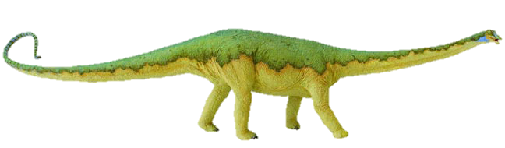
Long and short a sound sort
Sometimes it’s helpful to say that short sounds are short and bouncy, and to make a bouncing ball action as you say them; while long sounds can be stretched, exaggerating the sound slightly, whilst making a stretching elastic kind of movement.
Cut this top row off before you give the sort to pupils!

long vowel |  | 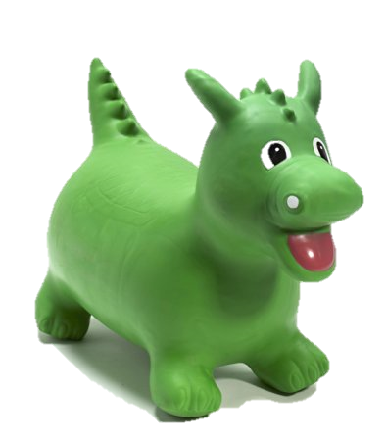  short  vowel
Sort by long or short sound – helps children to look for the single short e grapheme or to see it in combination with other letters to make a digraph with a long sound. Look out for oddballs (short sound in bread, deaf, long sound in we, she, me) | 
pea | seed | key
chief | people | these
the | bee | tree
seal | net | pet
peck | bed | elk
money | egg | elbow
eve | compete | phoneme
flea | bean | leaf
bread | deaf | toffee
freeze | sleep | hockey

